# IRC-OUSL 2025 – CMT Conference Management System

The submission and review of papers for the IRC-OUSL 2025 will be managed through an online conference management system called CMT. You can upload your paper, change details, check on the review status of your paper etc. using CMT conference management system.

Click the following link to access Microsoft CMT for IRC-OUSL 2025

<https://cmt3.research.microsoft.com/IRCOUSL2025>

If you have an account, enter your CMT credentials to access the site at login.

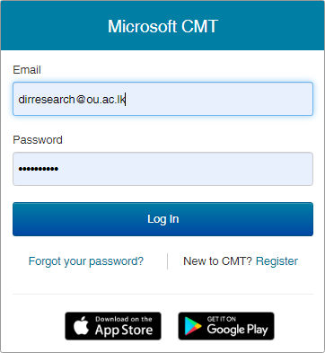

If you do not have an account in CMT, please refer to ‘create an account’ section of this document.

# Create an account

Step 1 : Navigate to site: <https://cmt3.research.microsoft.com/User/Login> Click “Register”.

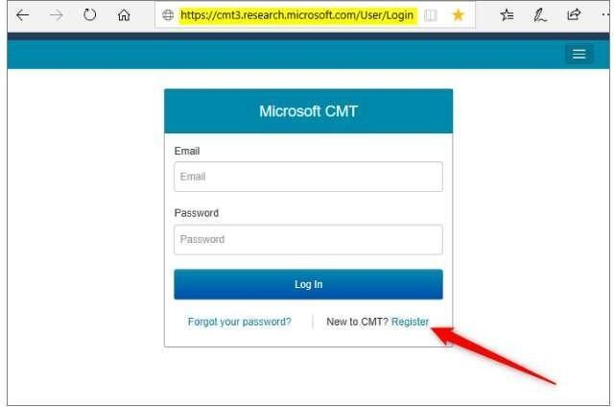

Step 2 : Enter your information in the 'Create New Account Page.' Fields with an <*> asterisk are required. (Note: the Google Scholar ID, Semantic Scholar ID and DBLP IDs are not required, however Chairs may require some users to have one or more.)

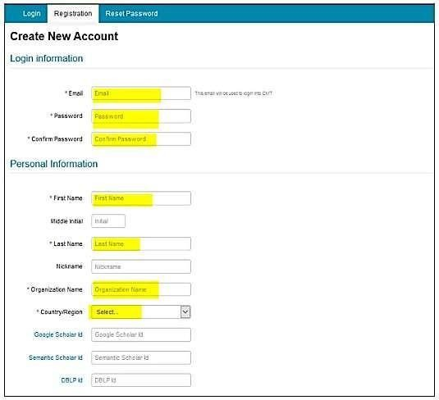

Step 3 : Enter the captcha characters, check the 'Agree to Terms of Use' checkbox and click ‘Register.’

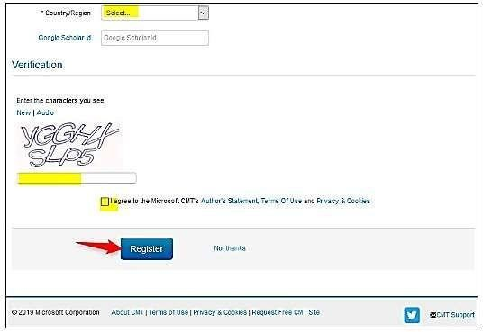

The “Welcome to CMT” page appears notifying you that an email was sent to you with a verification link.

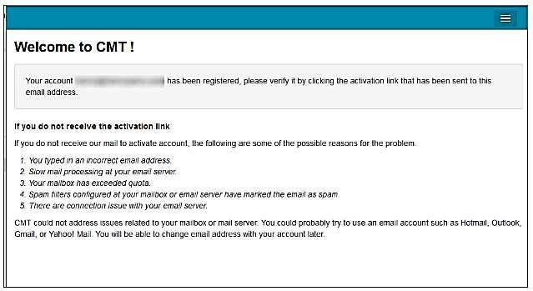

The email will look like this:

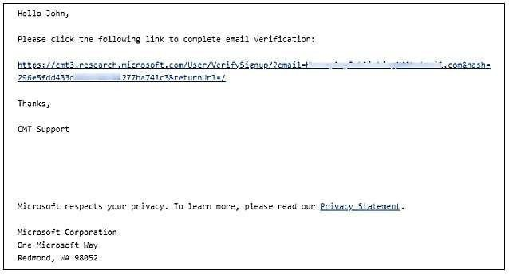

Step 4 : Once you click on the link in the email, you will see the Account Verification page. You can then use the “click here” link to log into CMT.

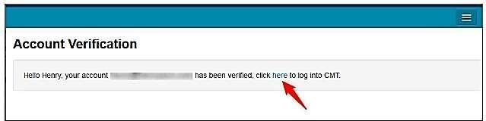

# Make a Submission

**Step 1** : After login, click on “All Conferences” to search for the **International Research Conference of the Open University of Sri Lanka 2025** to which you will submit your paper.

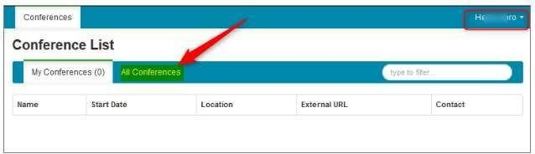

**Step 2** : Use the filter field in the upper right to search for the **International Research Conference of the Open University of Sri Lanka 2025**

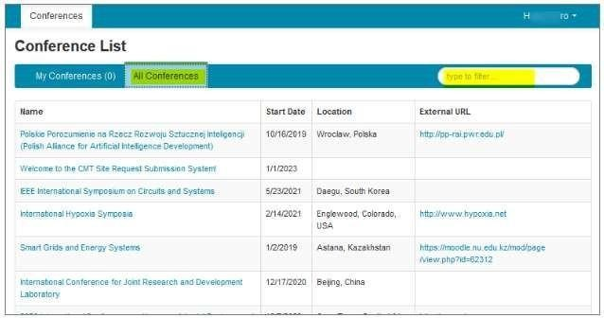

**Step 3** : Once you find the Conference, click on the Conference Name link.

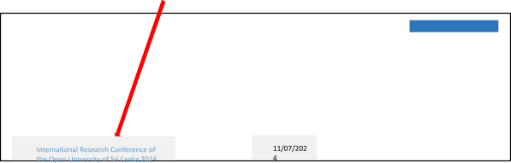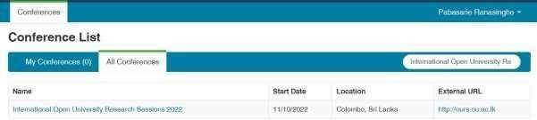

The Author Console page appears.

## SUBMIT TO THE CONFERENCE

Click on the “+ Create new submission” button.

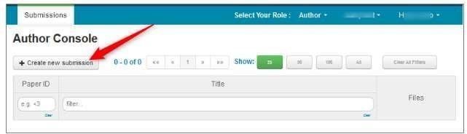

The 'Create New Submission' page appears.

## CREATE NEW SUBMISSION

Create New Submission page will look like the image below. The sections are:

Welcome message

* Title and Abstract
* Authors
* Subject Areas
* Files
* Submit and Cancel buttons

It is important to note that no files uploaded will be saved unless the Submit button is clicked.

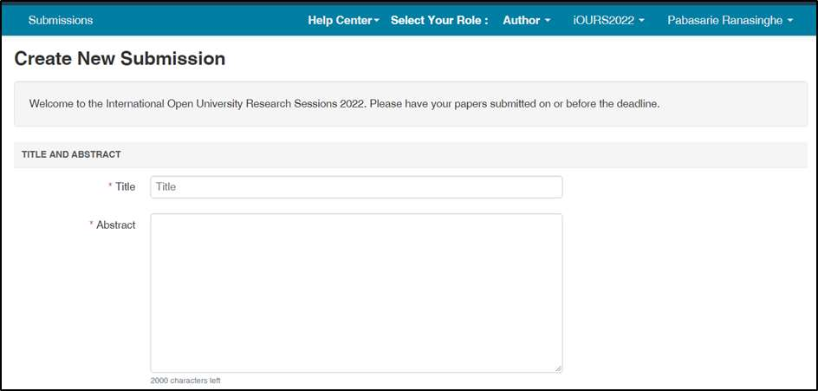

## TITLE AND ABSTRACT

The Title field is for the title of the paper.

The Abstract field is where you put the summary of your paper. Note, You need to upload one word file including Abstract and Extended Abstract.

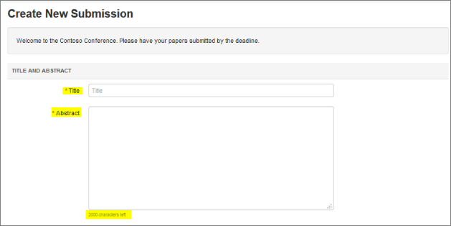

## AUTHORS

The Author section is prepopulated with your profile information and you are preselected as the Primary Contact.

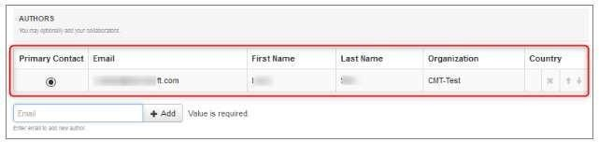

To add a co-author, enter the co-author’s email address into the field (in yellow below) and click add.

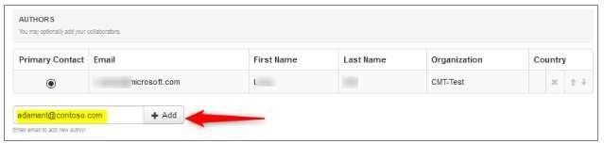

If the co-author you wish to add is not a user in CMT, you will see “User was not found. To add a new user, please enter information below and click Add Button.” If the co-author is already a user, the co-author will be added to the end of the Author list.

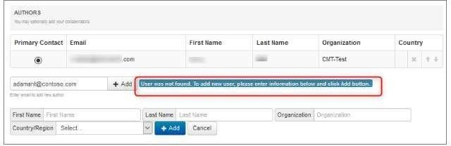

Enter the co-author’s first and last names along with the Organization to which he or she belongs and the Country/Region where they reside. Then click the Add button.

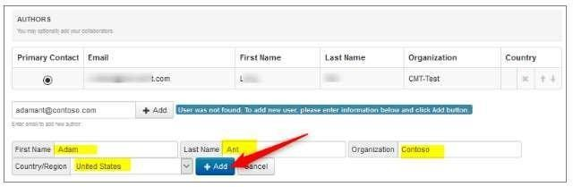

Once added, the co-author’s profile will appear in the list.

You may change the Primary Contact to the co-author by clicking Primary Contact radio button in co-author’s row. The ‘X’ and ‘arrow’ icons on the end of the rows are there so you may delete the entry and/or move it up in hierarchy.

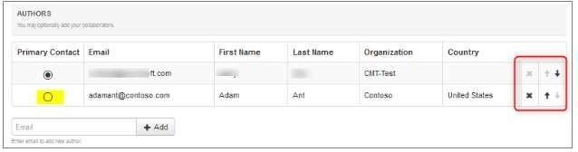

## SUBJECT AREAS

You will see Subject Areas section on submission form, Authors need to select a Primary Subject Area or optional Secondary Subject Areas which your paper belongs.

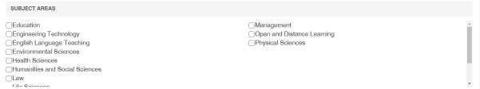

## FILES

To upload file for your paper, drag and drop the file into the dotted region or click the “Upload from Computer” button. Please note the number of files you may upload, the size and the type of documents allowed. Uploaded file will not be saved unless the Submit button at the bottom of the form is clicked.

## Note: It’s Compulsory to upload one word file including Abstract and Extended Abstract.

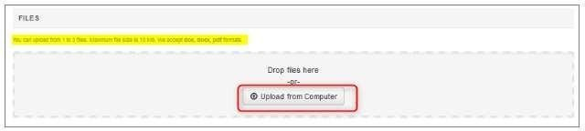

**SUBMIT AND CANCEL BUTTONS**

Once the form is filled out with all the required information, click Submit.



## EDIT CONFLICTS OF INTEREST PAGE

If the Chair enabled the 'Edit Conflicts of Interest' page, this page will appear after clicking Submit. If it is not enabled, the Submissions Summary page will appear. Edit this page by clicking on the “Edit” dropdown on the right and selecting all the appropriate boxes and click 'Done.' The Submission Summary page will then appear.

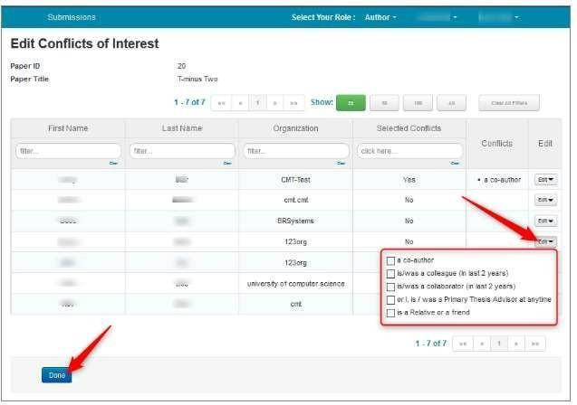

## CONFIRMATION EMAIL

Authors may also email a confirmation manually by clicking on the “Email” button on the right. You have the option to send it to yourself or all authors. Click send Email.

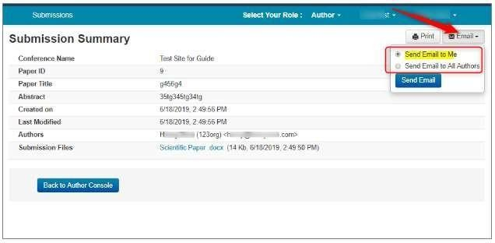

The email that the system sends to the Author(s) looks like this:

